In oorder to intergrate maven with Jenkins

1.Set the paths like

Set java path of particular machine

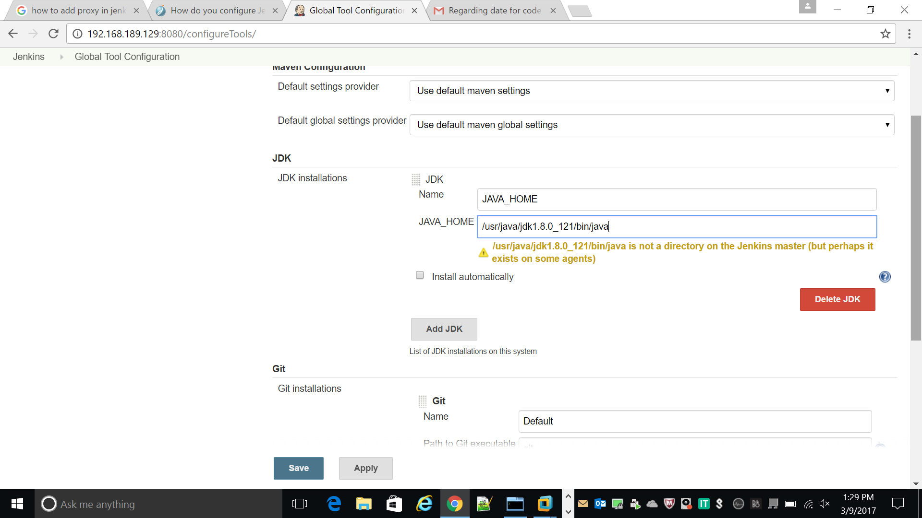

2.Set git path for clone code from git repositpory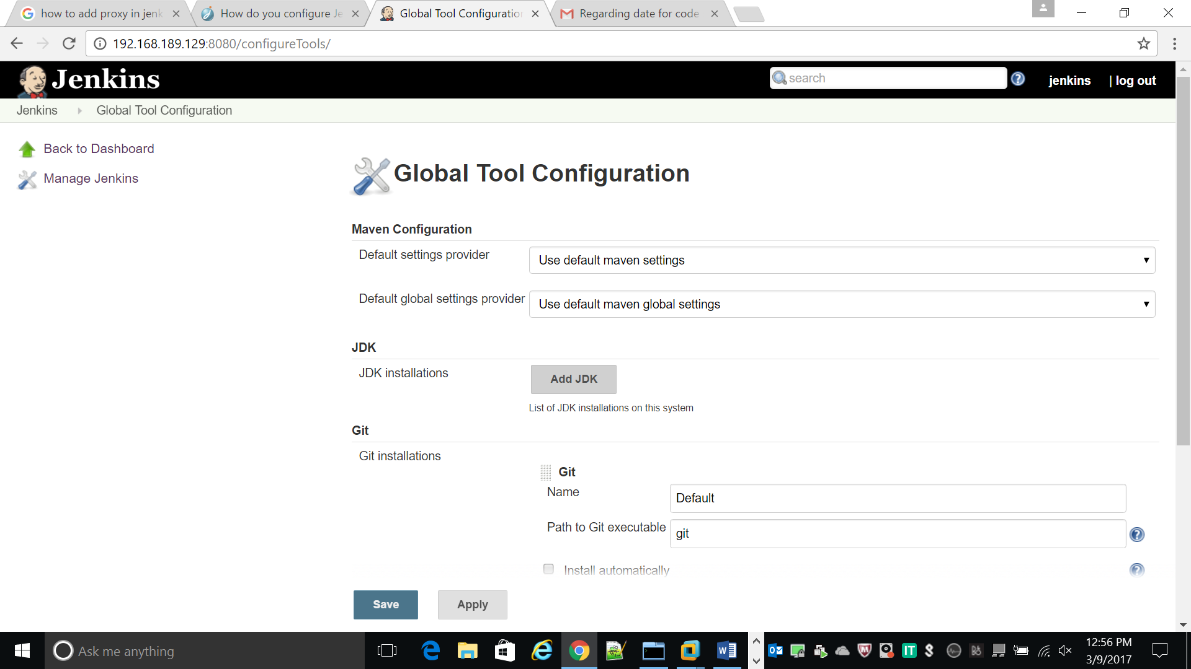

We have to set java and maven path in

Vi .bashrc

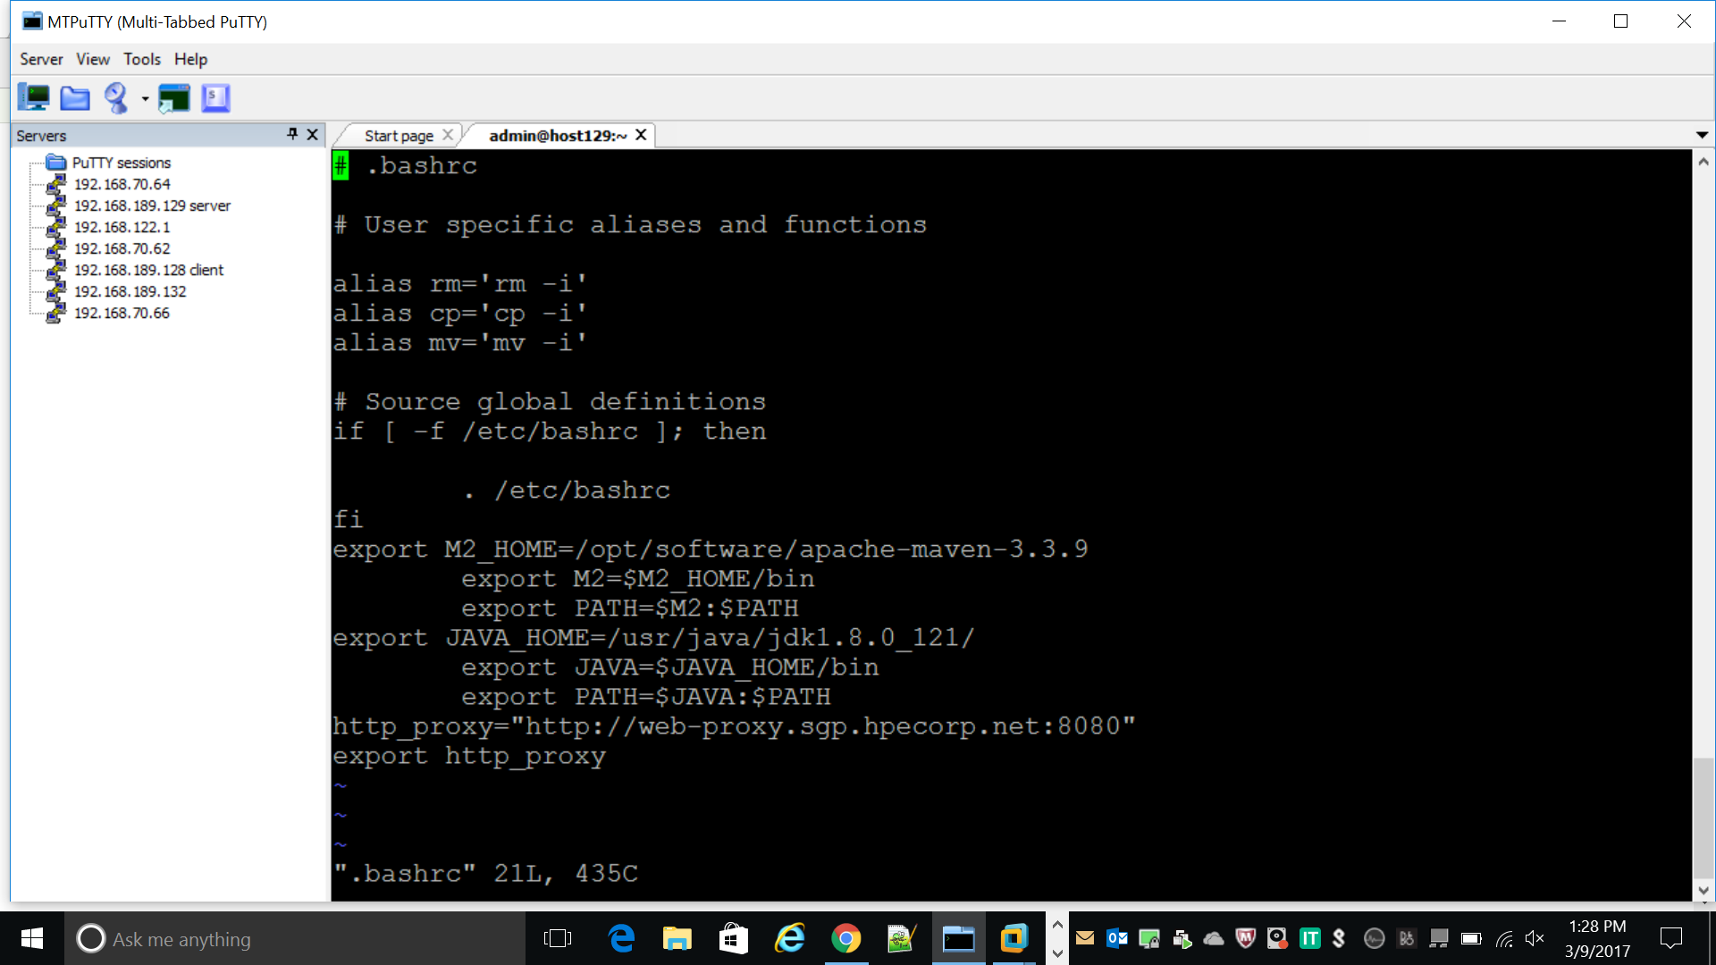

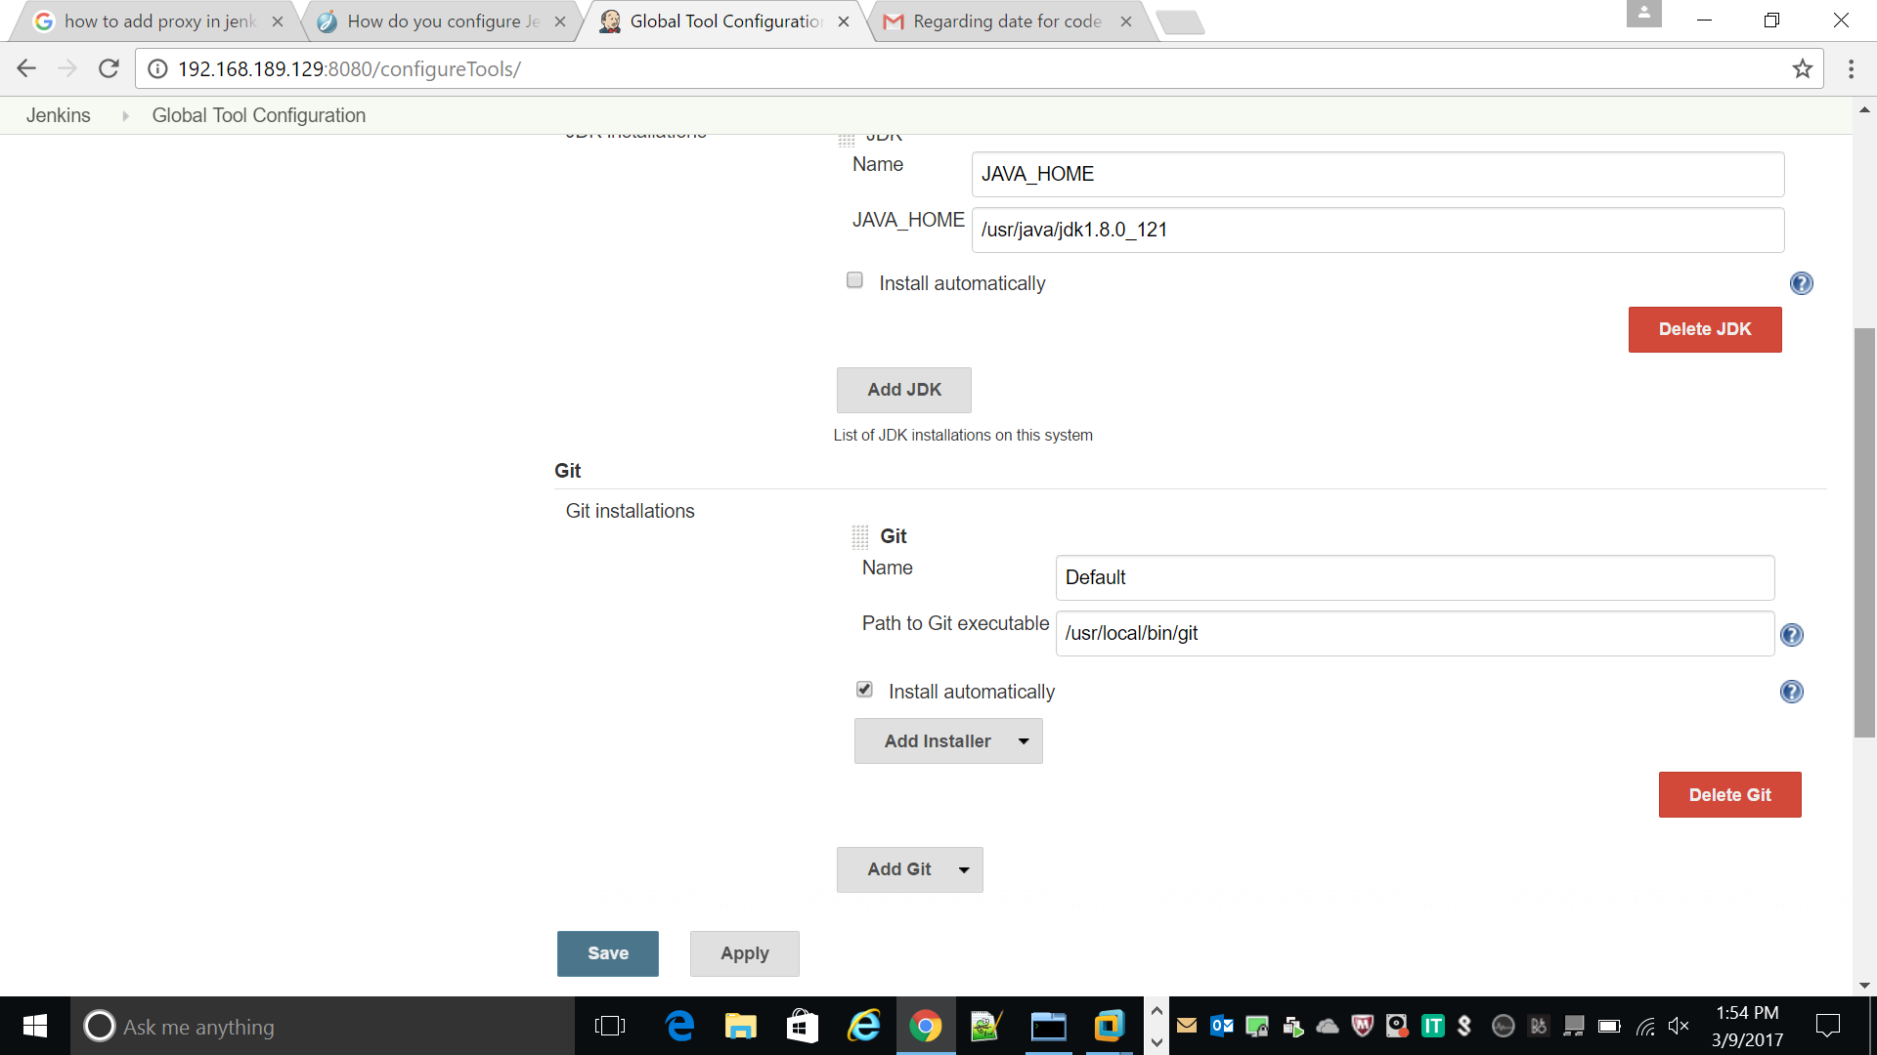

1. Set the maven path

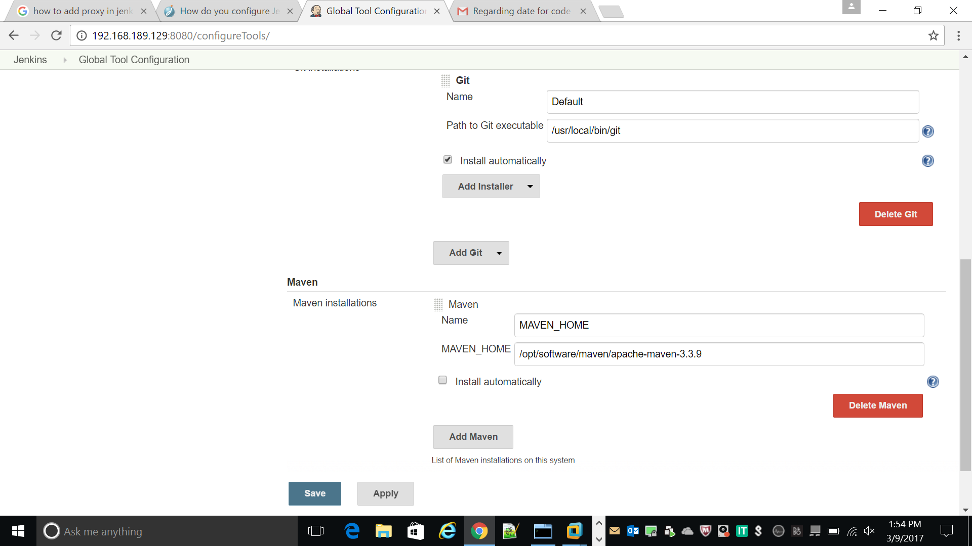

Save apply